PROJECT REPORT: AI-Based Smart City Network with Disaster Recovery
1. Executive Summary
This project demonstrates the design and implementation of a resilient and secure Smart City Network using Cisco Packet Tracer. The infrastructure integrates critical urban services such as emergency response, surveillance, and public connectivity. By utilizing VLAN Segmentation, OSPF Routing, and ACLs, the project ensures high availability and data integrity.
2. Main Objectives
The primary goals of this implementation were:
- VLAN Segmentation: Logically dividing departments to enhance security and traffic management.
- Dynamic Routing (OSPF): Implementing OSPF for automatic failover and intelligent path selection.
- Network Security: Using Access Control Lists (ACLs) to protect sensitive data and restrict unauthorized access.
- Disaster Recovery: Ensuring service continuity through backup systems and redundant routing.
- IoT Integration: Connecting and managing smart devices like CCTV cameras and sirens centrally.
3. Network Architecture
The system follows a Hierarchical Design for maximum efficiency:
A. Core & WAN Layer
Includes the ISP Router, Main-Router, and Backup-Router. OSPF is configured here to manage dynamic traffic.
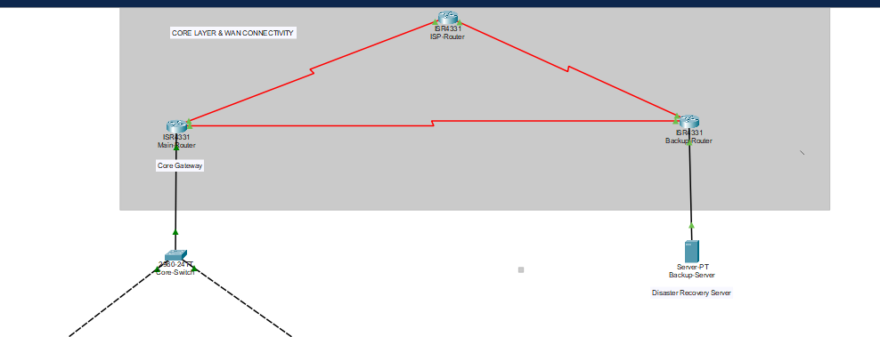
B. Distribution Layer
The Multilayer Switch acts as the backbone, handling Inter-VLAN routing and connecting all access switches.
C. Access Layer (Departmental Segmentation)
Devices are grouped into specific VLANs for better organization:
- VLAN 10 (Management): Hosts the Primary IoT Server.
- VLAN 20 (Emergency): Includes the Emergency PC and Siren.
- VLAN 30 (Residential): General users (Laptops, Smartphones via Access Point).
- VLAN 40 (Surveillance): IP Cameras and Monitoring PCs.
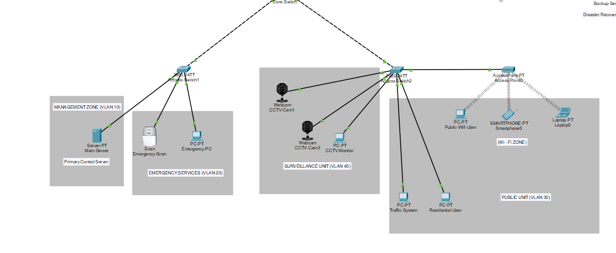

4. Technical Configurations & Features
I. Intelligent Traffic Control (ACLs)
Security is enforced using Standard and Extended ACLs on the Main-Router. For example, Guest users (VLAN 30) are restricted from accessing the management server.
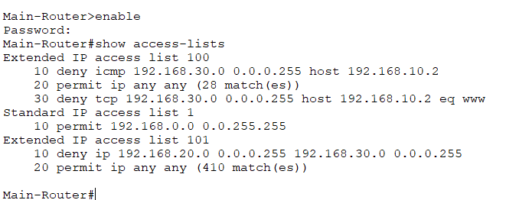
II. Disaster Recovery & Redundancy
A Backup Server (192.168.200.1) is configured to take over if the primary system fails. OSPF ensures that if a link goes down, the network converges instantly to a backup path.
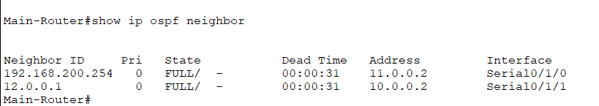
III. Smart City Control Portal
A custom HTML-based web portal is hosted on the Main Server, allowing administrators to monitor city status live.
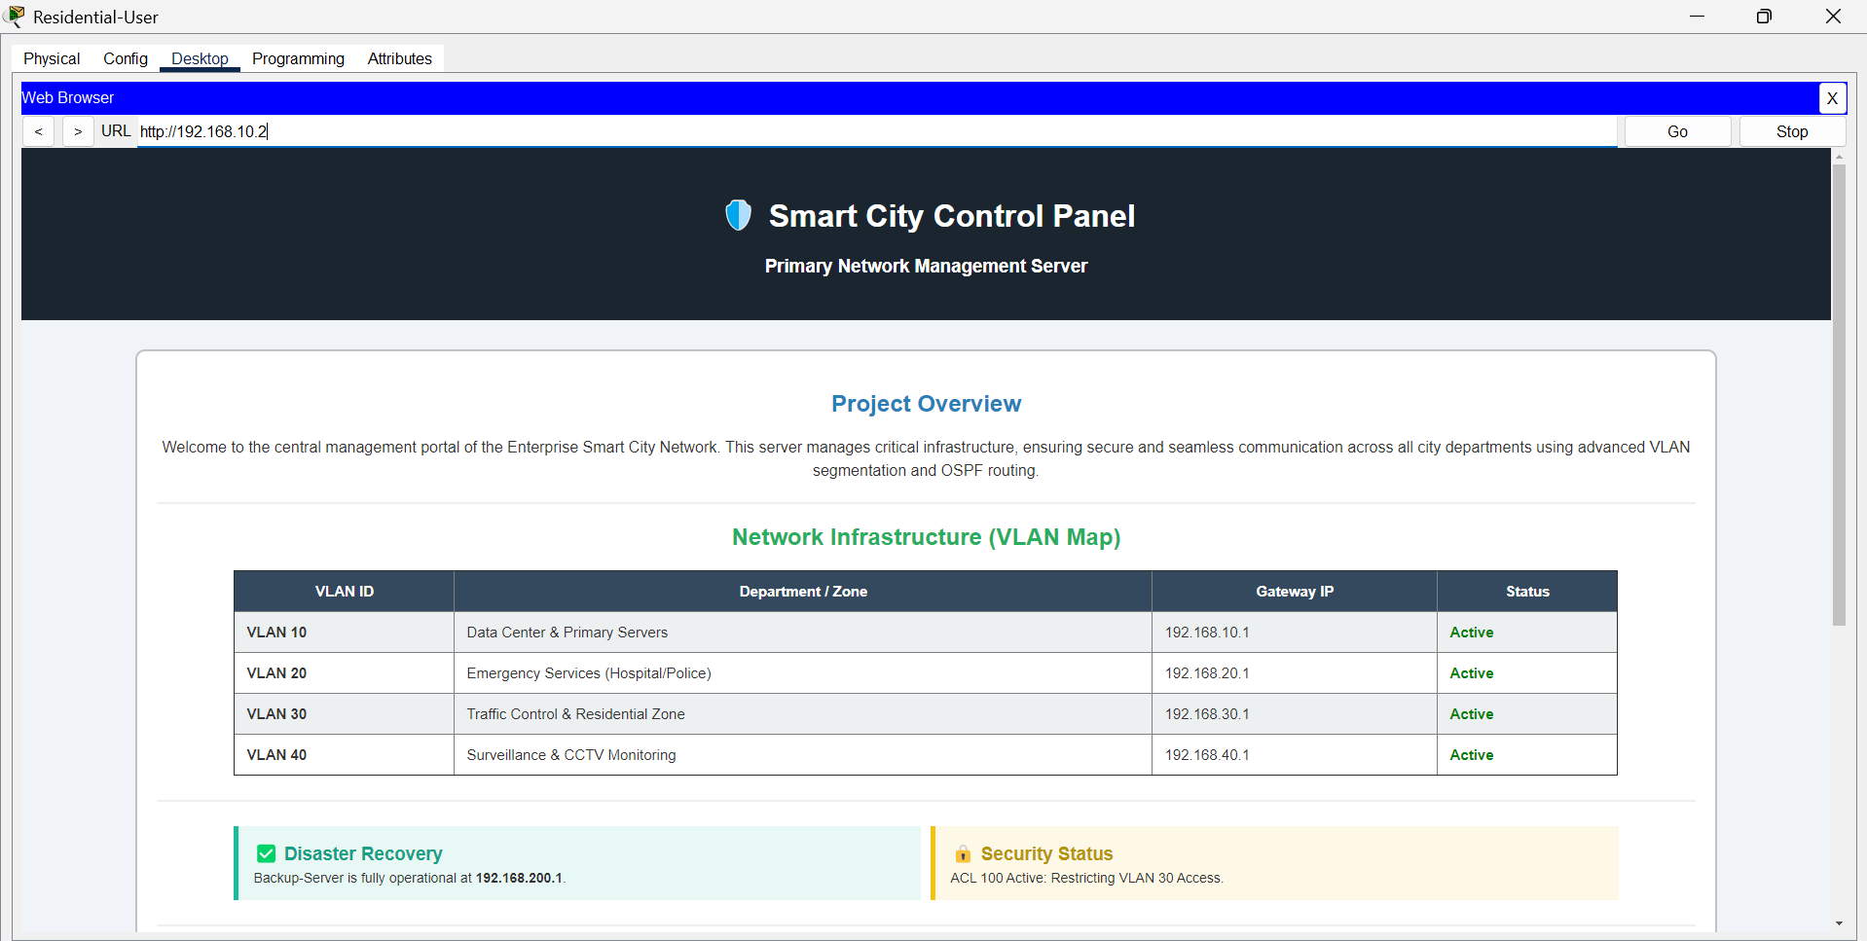
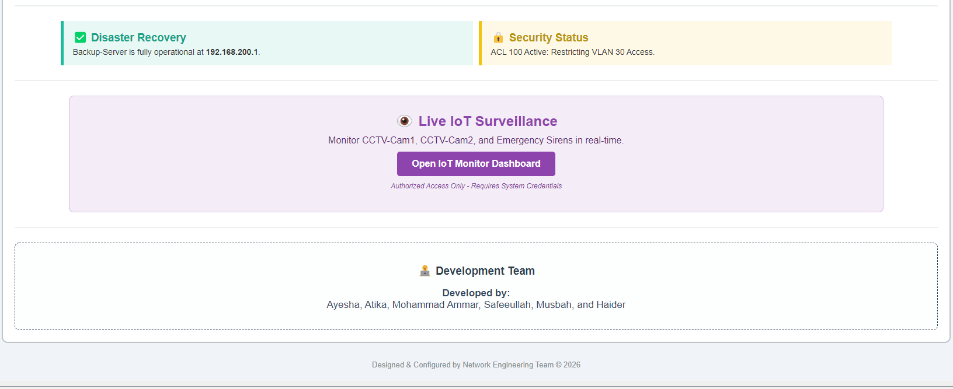

5. IP Addressing Scheme
Subnet / VLAN | Network Address | Gateway
VLAN 10 (Main Server) | 192.168.10.2 | 192.168.10.1
VLAN 20 (Emergency) | 192.168.20.0/24 | 192.168.20.1
VLAN 30 (Residential) | 192.168.30.0/24 | 192.168.30.1
VLAN 40 (Surveillance) | 192.168.40.0/24 | 192.168.40.1
Backup Server | 192.168.200.1 | --
6. Conclusion
The project successfully achieves a secure and highly available Smart City infrastructure. The integration of IoT, Disaster Recovery, and Automated Routing provides a blueprint for modern urban network management.
7. Project Team
- Ayesha Daudpota
- Atika Mughal
- Mohammad Ammar Hussain
- Musbah Tunio
- Safeeullah Sheikh
- Haider Khan

